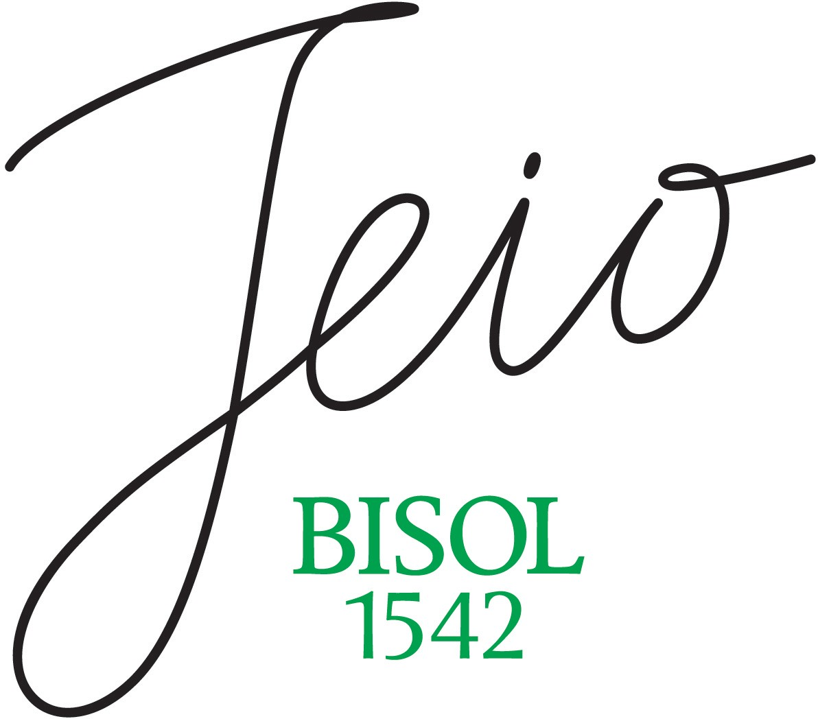

Jeio Prosecco Rosé
Prosecco rosè D.O.C

The DNA of the Bisol1542 brand is laden with intuition, the strength and ability to make bold, state-of-the-art choices, to seek out the new, like pioneers, and to embrace the changes over 21 generations whilst always striving for excellence. It is from this legacy and a profound cultural knowledge of the land and its fruits, that our new Prosecco DOC Rosé branded Jeio by Bisol1542 has taken root.

Vintage 2019

The Glera Tonda, harvested in September and selected for this first production, is a grape variety that was first mentioned in the area of Valdobbiadene, and then spread in a bigger area, in the 1500’s a century in which testimony state that the Bisol family were already nurturing grapes and making wine.The Pinot Nero of this vintage, harvested slightly earlier than the Glera, comes from a ‘CRU’ of 4 selected hectares chosen from the same area, near the town of Follina, Italian historic village in the heart of Veneto region.

After a rather cool winter, the zone saw a spring that was cooler and rainier than the norm, which caused a delay in bud-break and subsequently in all the phases of the growing cycle. This was followed by an appropriately hot summer, with temperatures that were typical for the season, which allowed us partly to recover the phenological development that had been lost during the month of May.

Bisol Desiderio & Figli S.r.l.
Via Follo 33 - 31049 Santo Stefano di Valdobbiadene, Treviso (TV) – Italia
t/ +39 0423 900 138 - f/ +39 0423 900 577 - bisol@bisol.it - www.bisol.it - bisolsrl@pec.it

Codice Fiscale / Partita IVA / Registro Imprese TV: IT 04618000261 – Capitale Sociale € 1.000.000,00 i.v.
Società con Socio Unico soggetta a direzione e coordinamento di Lunelli S.p.A. – Trento

